SOFTWARE TESTING
PRACTICAL REPORT
PRACTICAL REVIEW — PR-13

Student Name | Parth Fegade
Enrollment Number | 2504030100083
Programme | BCA — Semester 3
Practical | PR-13 — Selenium Environment Setup / WebDriver Test
Tools | Python, Selenium WebDriver, Google Chrome, PyCharm

1. Aim
To launch Google Chrome using Selenium WebDriver, open the Selenium website, print the page title and current URL, and close the browser session.

2. Objectives
- Verify that Python and Selenium are available in the PyCharm project environment.
- Start Chrome through Selenium WebDriver and maximize the browser window.
- Navigate to https://www.selenium.dev/ and read the page title and current URL.
- Confirm that the browser automation script runs without an execution error.
- Close the browser session cleanly after the test.

3. Software and Requirements
Component | Purpose
Python | Runs the automation script.
Selenium WebDriver | Controls the browser using Python.
Google Chrome | Browser launched and controlled by WebDriver.
PyCharm | IDE used to write and execute the Python script.
Selenium website | Target page used to verify browser navigation.

4. Procedure
- Open the Python project in PyCharm.
- Create a Python file named pr13.py or tutorial13.py.
- Install Selenium in the selected interpreter using: pip install selenium.
- Write the Selenium script shown in Section 5.
- Run the file from PyCharm.
- Observe Chrome opening https://www.selenium.dev/ and check the title and URL printed in the Run console.
- Confirm that the script ends and the browser closes.

5. Program Code
from selenium import webdriver

driver = webdriver.Chrome()
driver.maximize_window()

driver.get("https://www.selenium.dev/")

print("Browser launched successfully")
print("Page Title:", driver.title)
print("Current URL:", driver.current_url)

driver.quit()

6. Code Explanation
Code statement | Explanation
from selenium import webdriver | Imports Selenium's WebDriver interface.
webdriver.Chrome() | Starts a Chrome browser session.
driver.maximize_window() | Maximizes the browser window.
driver.get("https://www.selenium.dev/") | Opens the Selenium website.
print(...) | Displays a confirmation message, page title, and current URL.
driver.quit() | Closes the browser session.

7. Evidence Screenshots
The following screenshots were supplied as practical evidence. They show the Python script, Chrome opening the target site, the loaded Selenium homepage, and the PyCharm Run console.
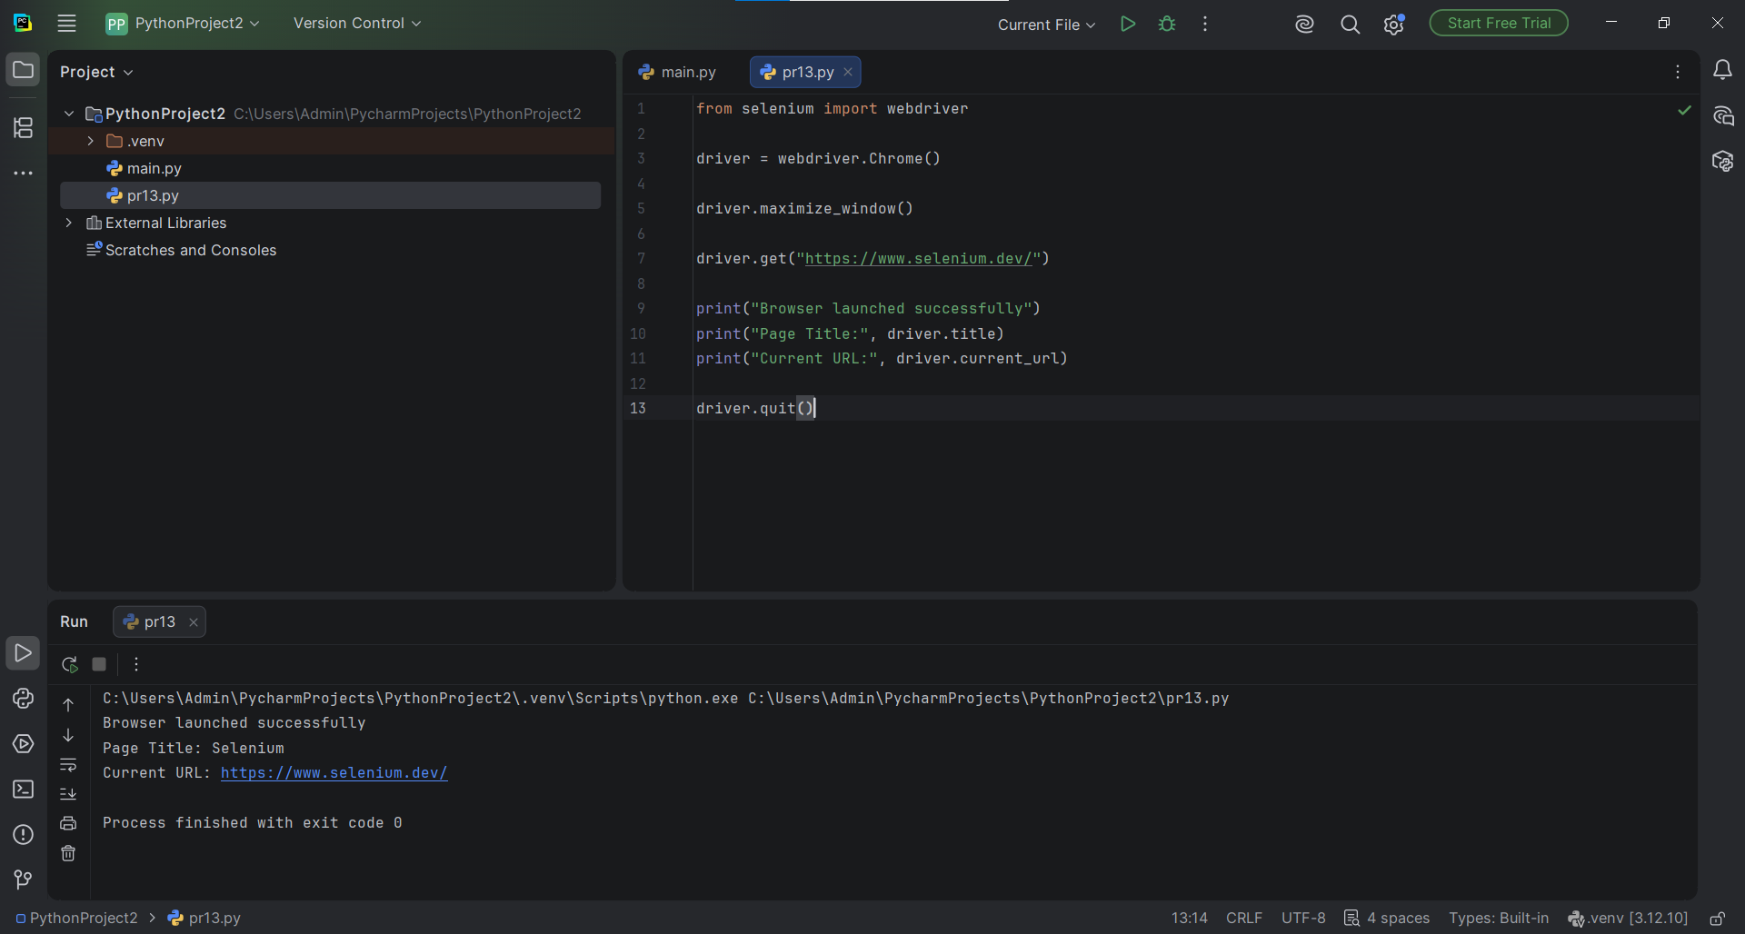
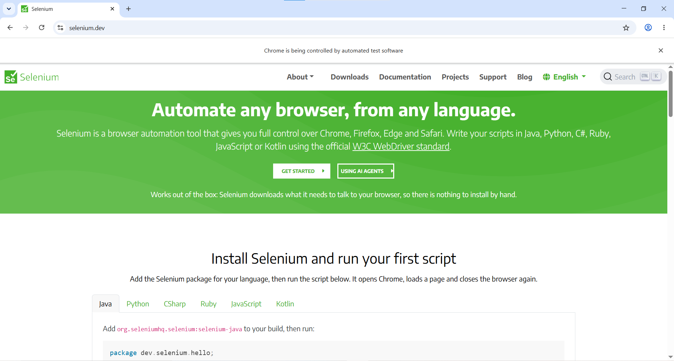
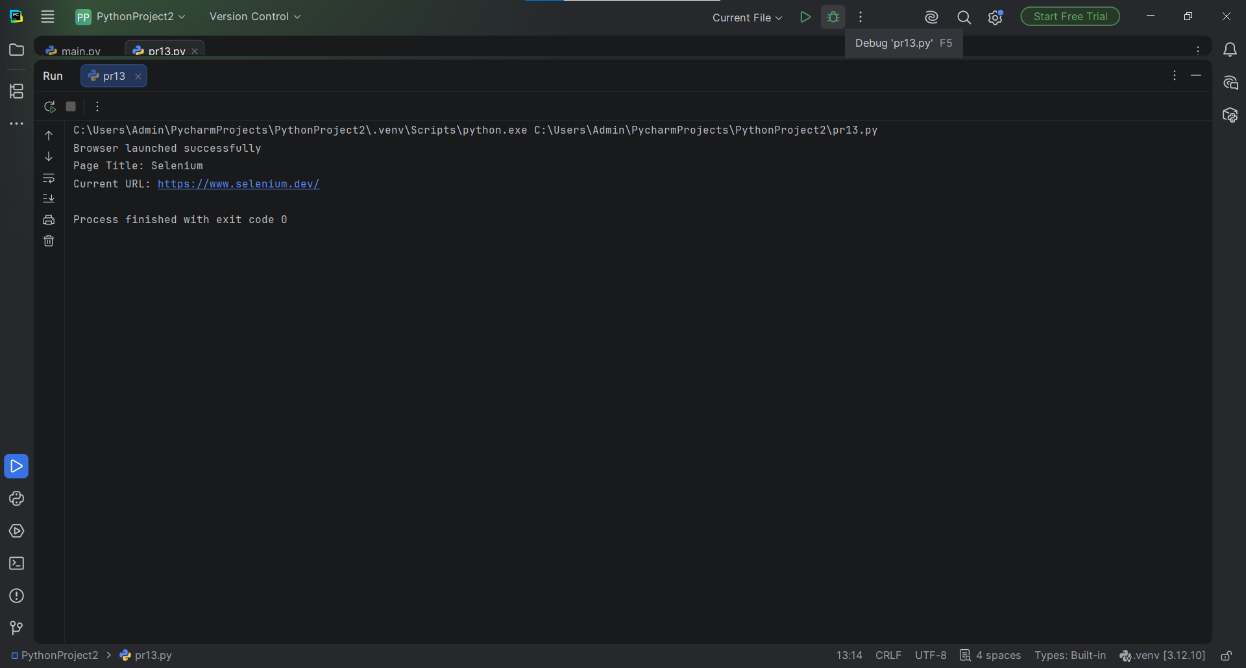

8. Test Case Summary
Test ID | Test activity | Expected result | Observed result / status
TC-13-01 | Launch Chrome | Chrome opens without WebDriver error. | Chrome launched; Pass
TC-13-02 | Open Selenium website | Selenium homepage is displayed. | selenium.dev loaded; Pass
TC-13-03 | Print page details | Title and URL appear in console. | Title: Selenium and URL printed; Pass
TC-13-04 | Close browser | Browser session closes cleanly. | Process finished with exit code 0; Pass

9. Observations
- The Python script uses Selenium WebDriver to start and control Google Chrome.
- The browser opens the Selenium website at https://www.selenium.dev/.
- The Run console shows “Browser launched successfully”, the page title “Selenium”, and the current URL.
- The process finishes with exit code 0, indicating successful script completion.

10. Result
The Selenium environment test completed successfully. Chrome was launched, the Selenium website was opened, the page title and URL were printed in the console, and the browser session was closed.

11. Conclusion
This practical demonstrated the basic configuration and use of Selenium WebDriver with Python in PyCharm. The successful browser launch and console output confirm that the automation environment is functioning.

